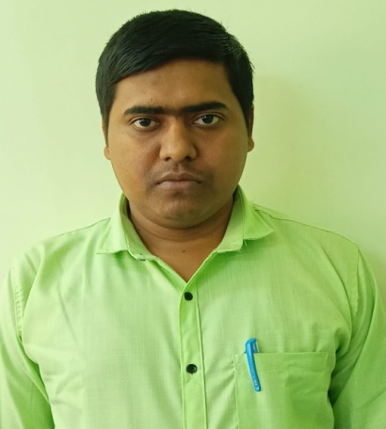
Format of Curriculum vitae (CV)

Name: ARABINDA DEY
Designation: Assistant Professor
Institution Name: Kharagpur College
Department: Philosophy
Mobile No: 8972017030
Email Address: arabinda2018dey@gmail.com
Qualification: M.A., M.Phil.
Teaching Experience: 2 years
Research Experience and Area: Pursing Doctorial research work , Research area: The Concept of Substance from Western Perspective.
Publications in International Journals: NA
inNational (UGC Listed) Journals: NA
Chapter in books Published: 02
Development of e-learning study module: NA
Presented Paper in Seminar: “Sambidhan Anumodita Samrakhan Byabosthar Parjalochona”, National Seminar, Organised by- Vidyasagar University Philosophy Alumni Association.
Delivered Invited Lecture: Yes
Research Projects: NA
Research Guidance: NA
Fellowship/Award/recognition received: NA
Editor or Reviewer of a Journal: NA
Organized Workshop: NA
Administrative responsibility: NSS Programme Officer
Participation in Board of Studies: NA
Members in different Committee: NA
Contribution to Professional Bodies: NA
Any other:

