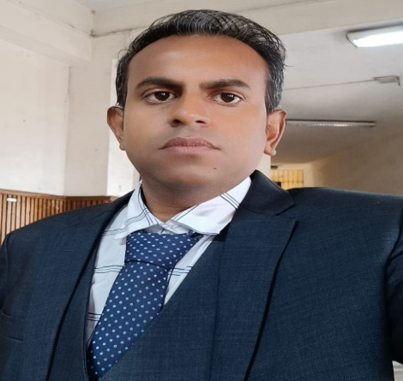

Dr. Gauranga Das
Assistant Professor
Department of Philosophy
Kalimpong College, Kalimpong, West Bengal, India
Pin Code No. - 734301
+91 8617484758
gdasindianphilosophy@gmail.com

Dr. Gauranga Das is currently an assistant professor of philosophy at Kalimpong College,which is affiliated to University of North Bengal, Raja Rammohunpur, Darjeeling, West Bengal, India.

Dr. Das received his Master of Arts (M.A.) from the Department of Philosophy, University of North Bengal and his Doctor of Philosophy (Ph.D.) from the University of Gour Banga in Malda, West Bengal, India with a thesis titled "Dharma and Moral Autonomy: A Critical Study."

He teaches Indian Philosophy, Western Philosophy, Social Political Philosophy, Ethics (Indian and Western), and Philosophy of Religion since 13 February 2017. He has delivered many invited talks/lectures in different colleges.

His main areas of interest are Indian philosophy, ethics of the East and the West, and the study of Dharmaśāstra. He worked with the Indian Council of Philosophical Research (ICPR) in New Delhi as a research fellow. In addition to publishing more than 30 research articles and book chapters in several reputable peer-reviewed, UGC-approved, and Care Listed journals and books, he has presented numerous national and international papers at various colleges and universities.

He has proved his administrative efficiency as Convener of Student Grievance and Redressal Cell and Member of NAAC committee, Academic committee, and Research committee of Kalimpong College. He was Organizer and Convener of ICPR-Sponsored International Seminar on Yoga and National Seminar on Indian Ethics at Kalimpong College.

He has completed Training Programme of Research Methodology of 21 Days from HRDC, Gauhati University, and recently Five-Day International Workshop titled “Indian Traditional Knowledge: Intellectual Property and People’s Rights” Debra Thana Sahid Kshudiram Smriti Mahavidya (Autonomous), affiliated to Vidyasagar University, Paschim Medinipur, West Bengal, India.

He is a Life member of the Journal of Indian Council of Philosophical Research (JICPR) and Indian Philosophical Congress (IPC), New Delhi.

